Authentication and Authorization

Spis treści

Authentication and Authorization Basics 3

Definition 3

Adding Cookie Authentication 3

Login and Out 4

Cookie 5

External Identity Provider 6

Multiple identity providers 8

Implementing Auth wit Asp.Net Core Identity 10

Definition 10

Configuration 11

Managers 14

Working with claims 14

Roles 16

Email functionality 17

Two factor Auth 19

External Identity Providers 22

OpenIDConnect 24

Definition 24

Implementation 27

PkCe 28

Create your own Identity Server 29

Single Sign On 30

Configure Identity Provider 31

Protecting API 31

Applying Auth 33

Definition 33

Configuration 33

Use in View 34

Requirements and Handler 34

Proposal 36

Auth API 38

# Authentication and Authorization Basics

## Definition

Authentication is an access to application with login and register mechanic. Without authentication there is no authorization.

Autherization is access to particular operation in software.

## Adding Cookie Authentication



AddAuthentication in services with Default Cookie Auth

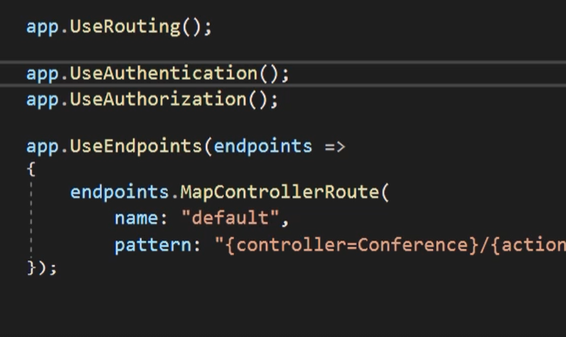

Then add authentication and authorization between routing and endpoint because this is pipeline when each element is added after the one before and order has matter. When dev adds a auth mechanism after endpoint then request will be send to customer without auth because is after endpoint.

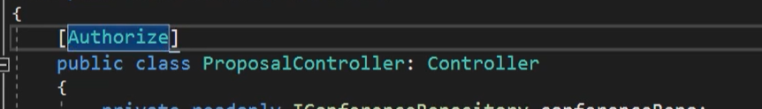

Basic filter of Auth is an Authorize. Users which aren’t authenticate doesn’t have access to controller.



To this filter can be added different polices roles and AuthSchemas.



Can be used on methods too.



Can be added as global auth, but always in app is views available to all user and available for specific type of user.

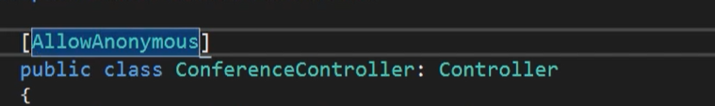

Is filter which give access to all user.

## Login and Out

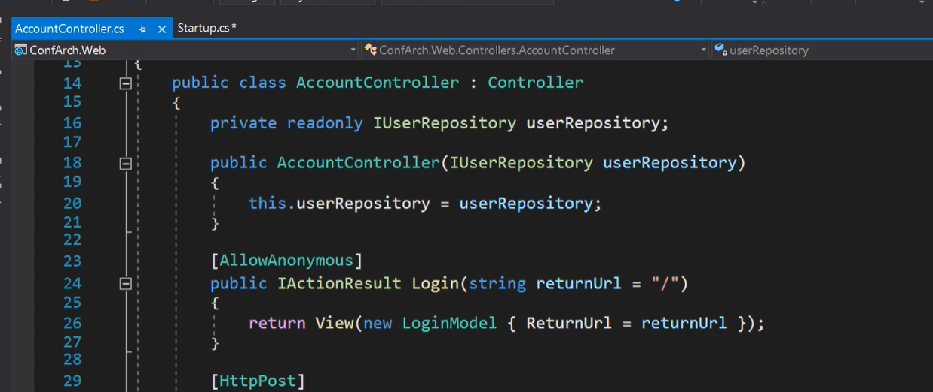

Create method in controller

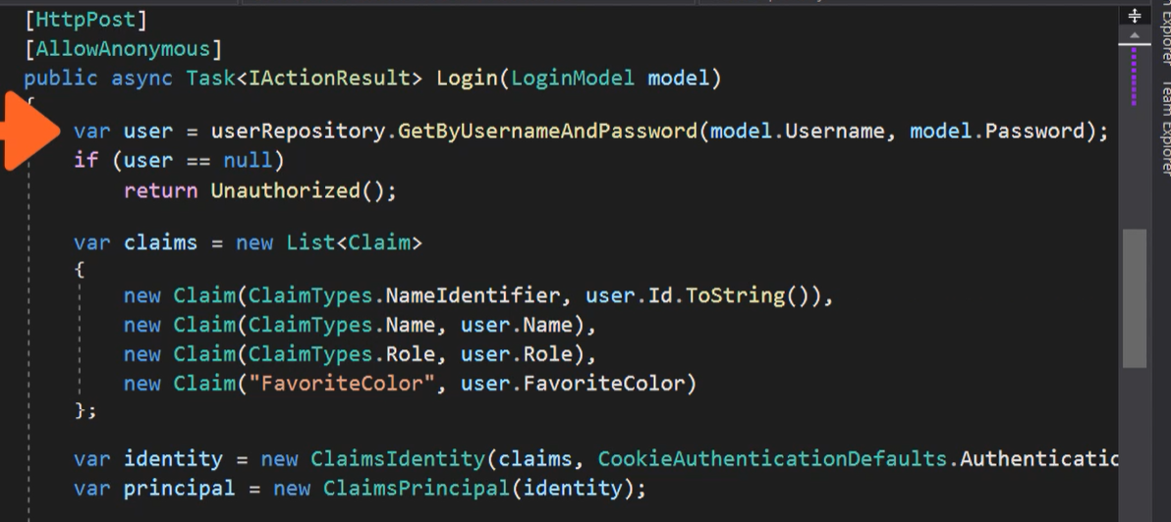

And post method. First part of code return user with specific username and password. Then is List of claims which is a state of entity which give acces to particular operation. There are two type of identityDB based on role or based on claim.

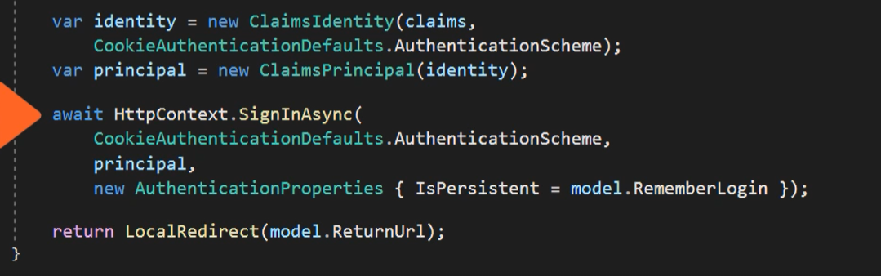

Then is a ClaimIdentity with claims and schema of auth. Principles is object represent users.  
SignIn method invoke from HttpContext object (session provider) need two params schema. Object with claims rules and AuthPropertis.

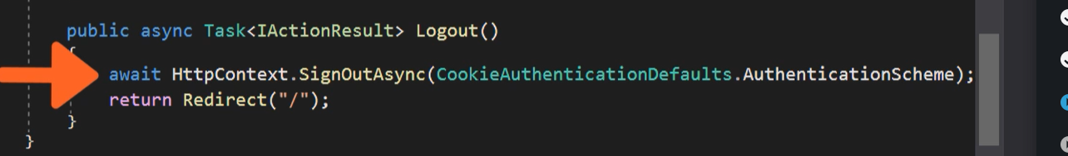

Logout is only method and redirect.

## Cookie

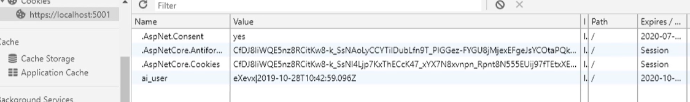

Identity cokkie has been created and sent to Browser. When user close browser still be login in with cookie. Cookie needs a expire time because user will be logged forever or to log out operation.

After Logout cookie disappear form browser.

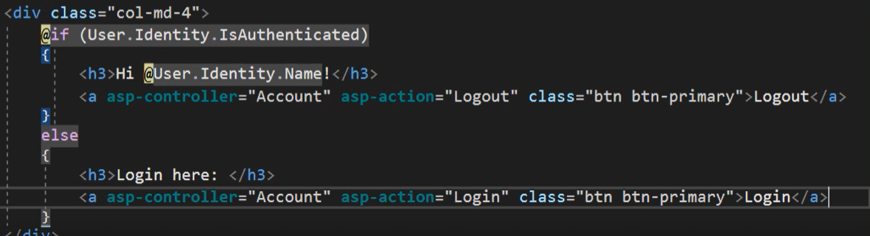

Saved claim give access to sate of objects.

## External Identity Provider

Cookies created by asp.net core identity is a internal provider. External is a 3rd part app like created by Facebook, Microsoft, Google which create token. This token will be process and after this operation based on Google token will be create identity cookie will sent to browser.

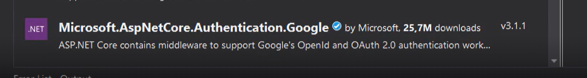

But to use external provider required is an package supported OpenId or OAuth 2.0

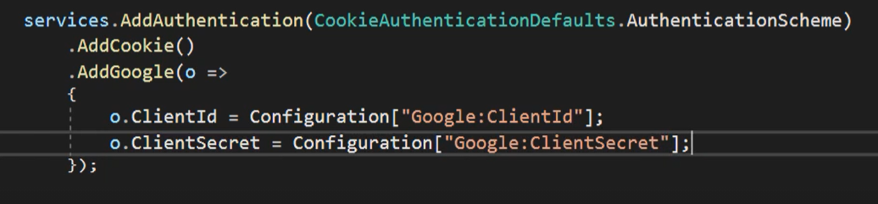

Then add service with options like id and secreat copied from Google’s site.

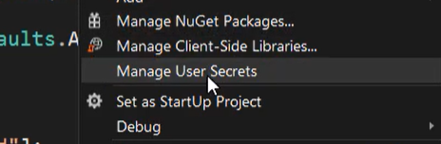

Add secret to json file

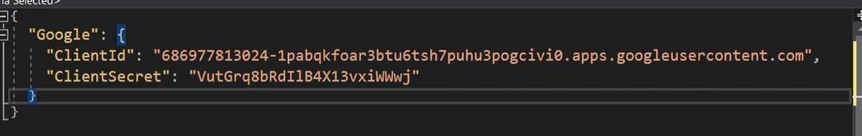

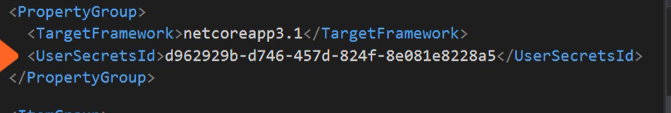

Or pasted to project file

Or

Create via CMD.

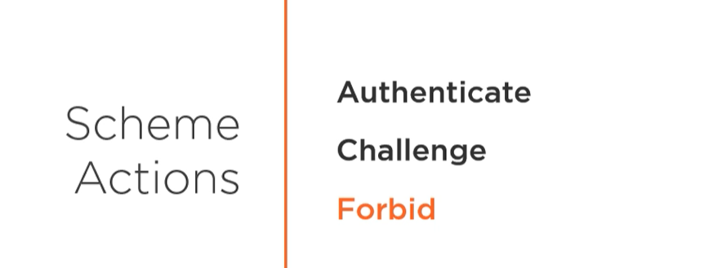Three action firt is login and logout. Second is redirect to login when user is not logged in. Third one is when user doesn’t have access to action.

With external provider you need to login providers website.

## Multiple identity providers

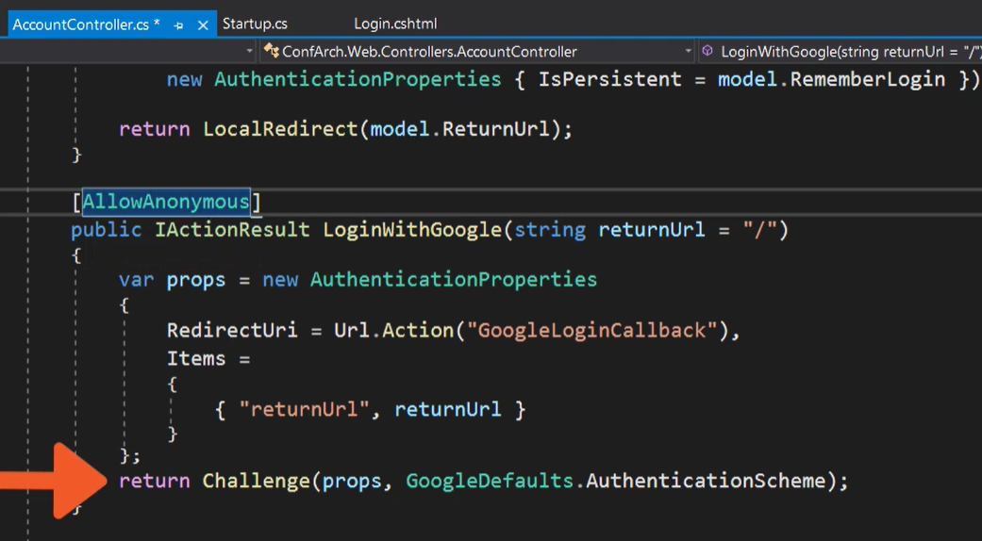

Create login action to external provider. Wit redirect to our app.

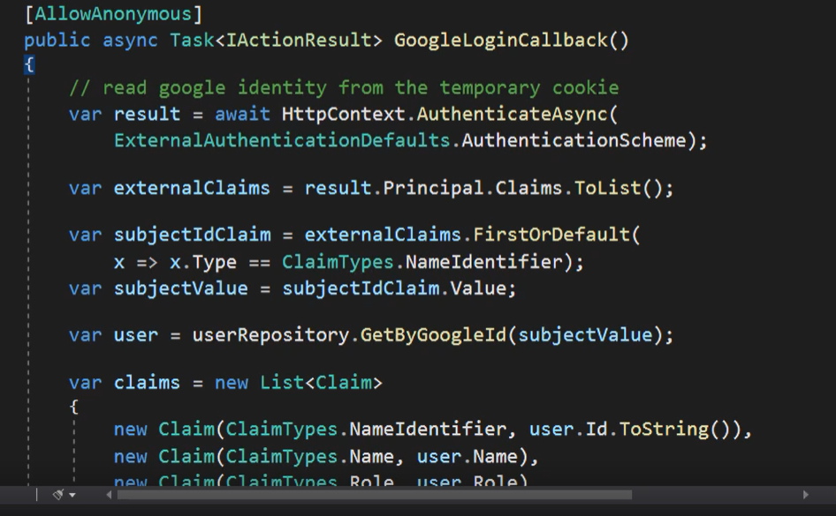

Create claims with post.

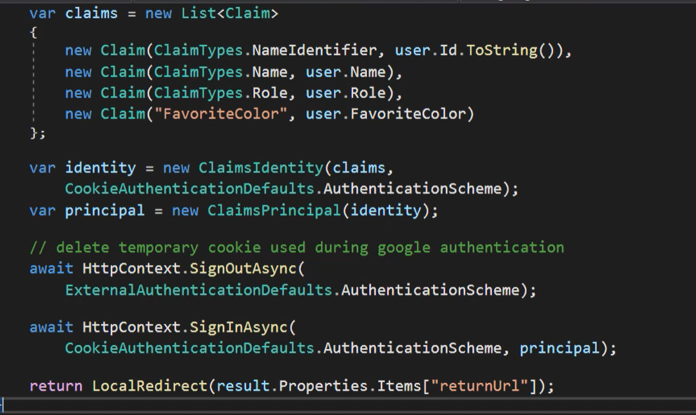

And rest of code like in internal provider.

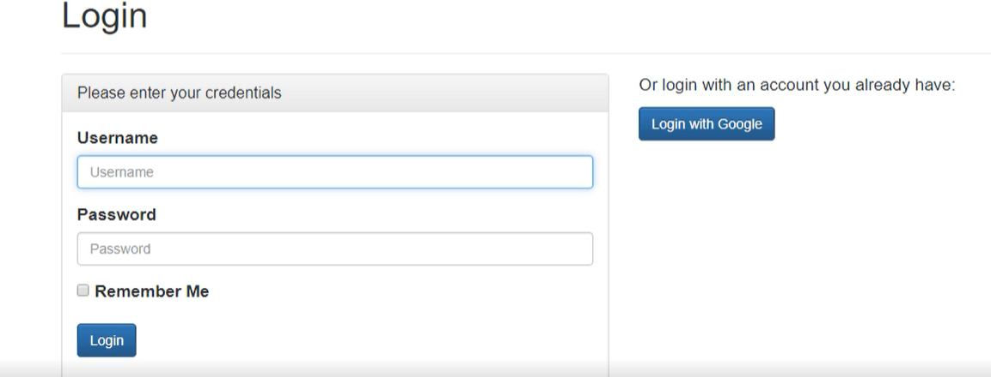

Now It’s both of providers.

# Implementing Auth wit Asp.Net Core Identity

## Definition

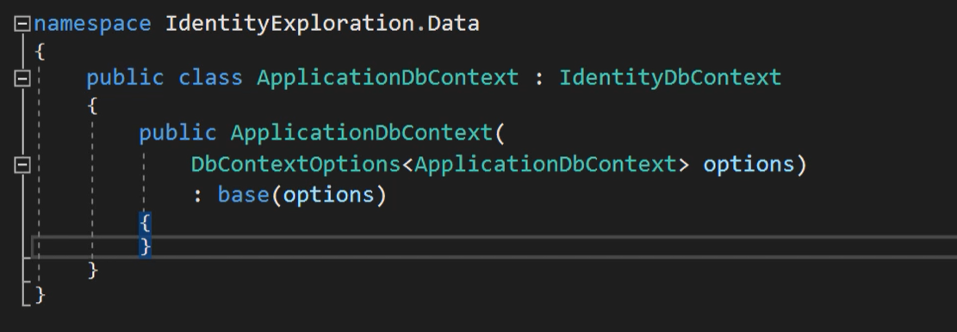

Do you know that? Don’t you? It’s the most uses identity. It is part of Microsoft aps.net core and can be added with one click when dev creates app.

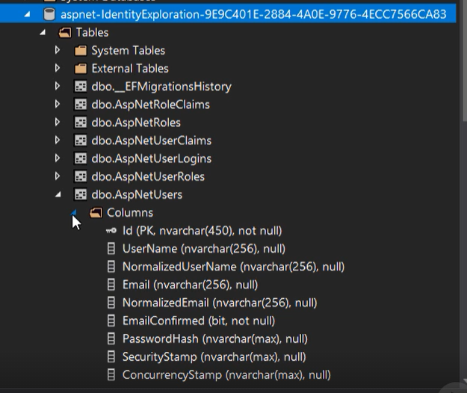

After migration and update db all tables from IdentityContext will be added.

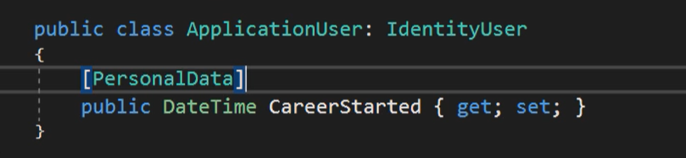

To extend ASpNetUSers table create AppliucationUser with inheritenced properties from IdentityUser class.

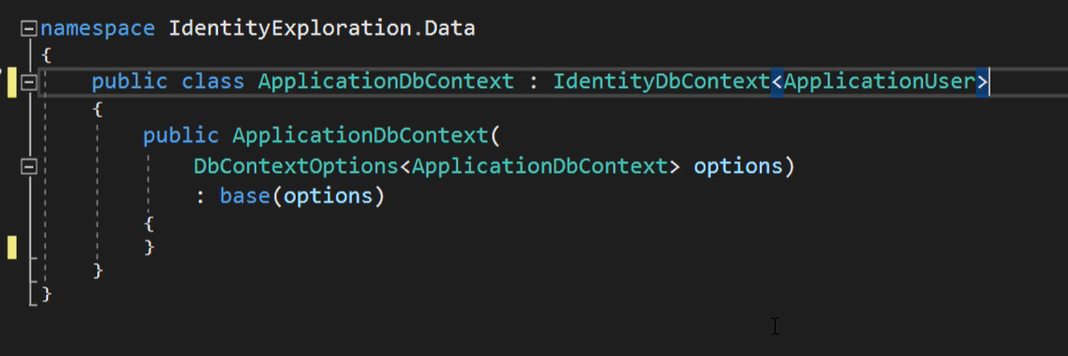

After that attach generics type param to DbContext and add migration and update db.

## Configuration

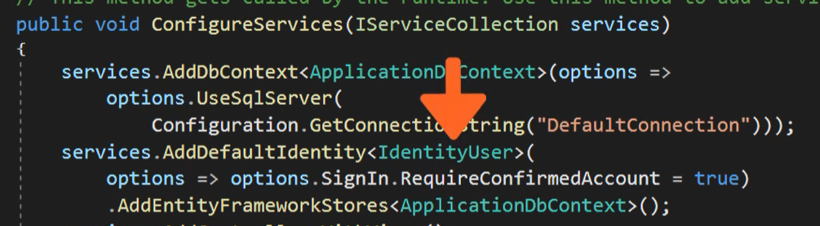

Configuration is added by default. But first method added DbContext. Second add default Indentiti and Framowork stores of course everything is related to DbContext with Identity.



But in our app DefaultIdentity is a Application user so change this code.

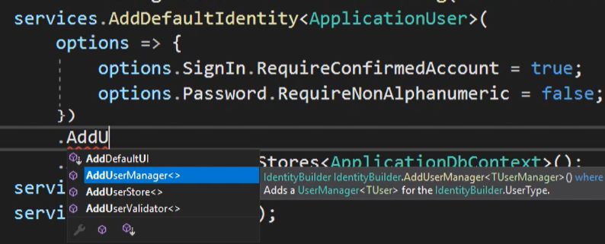

Options can configure everything which is related to Auth like password account confirmation, etc and of course to app can be added configured AddUserManager but of course is default version created by Ef Core Identity package.

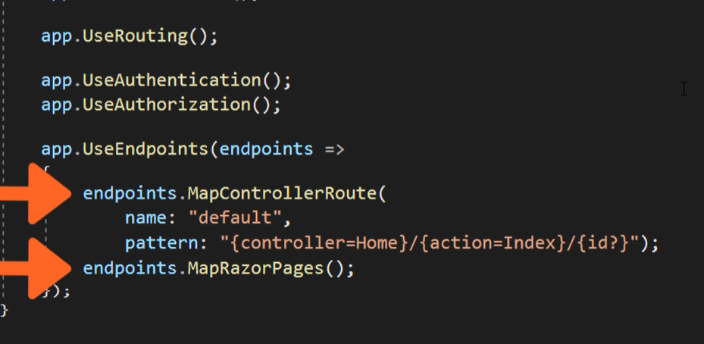

Add Auth in pipeline if is lack of, but of course is added by default.

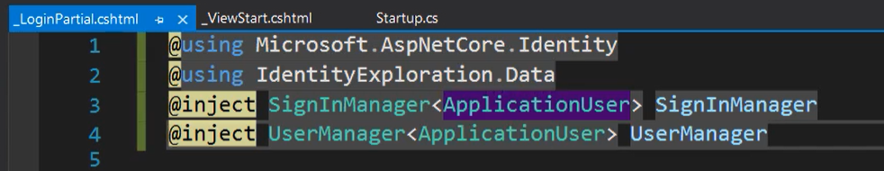

Change sign and user manager to our identity and save after that it can be login and regiseter view reached.

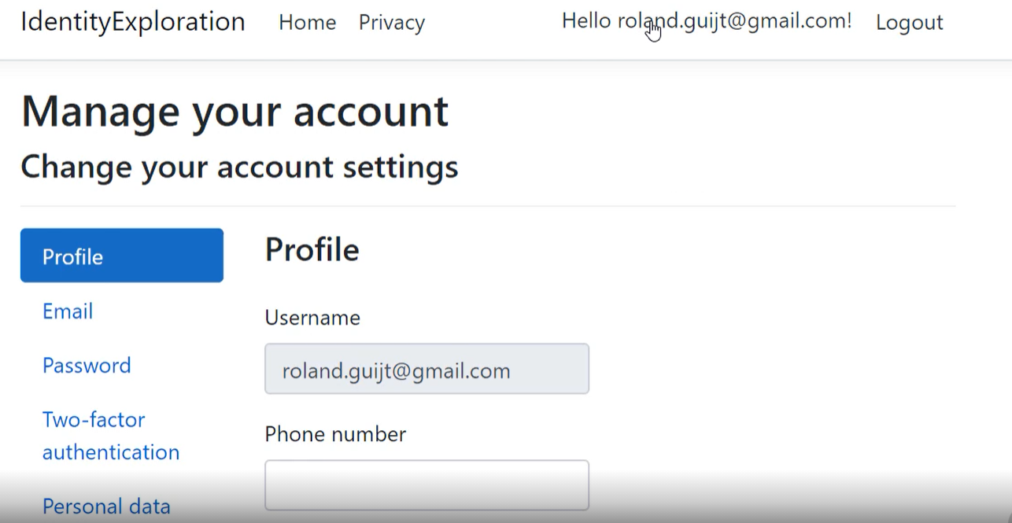

But of course view can be appear. Just add scaffolded item and choose identity and login and register part of razor page. View with code behind will be generated and it will be palaced in area folder. After that add service with razor pages.



## Managers

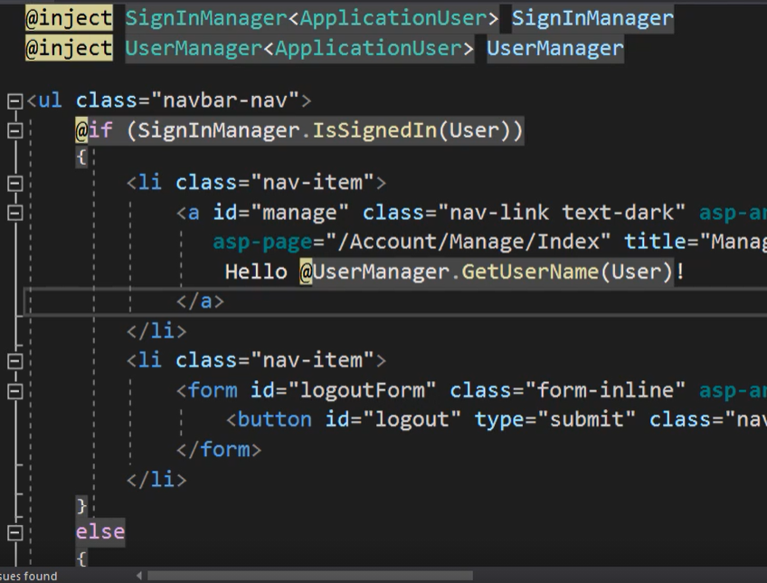

The have all information about session.

## Working with claims

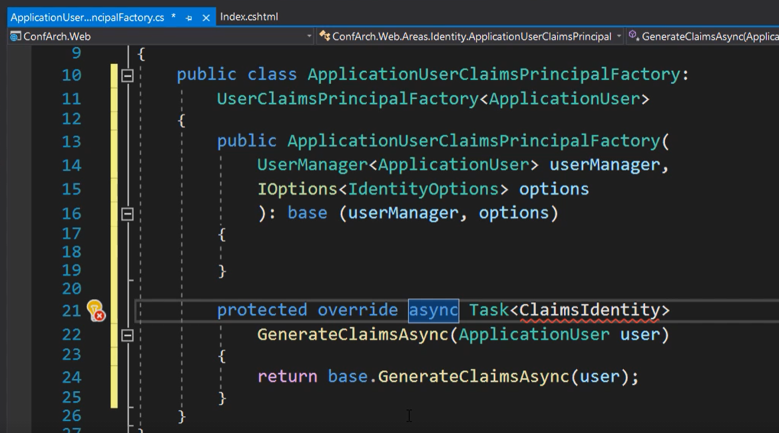

Create factory which inherit prop from user claim… with your identity

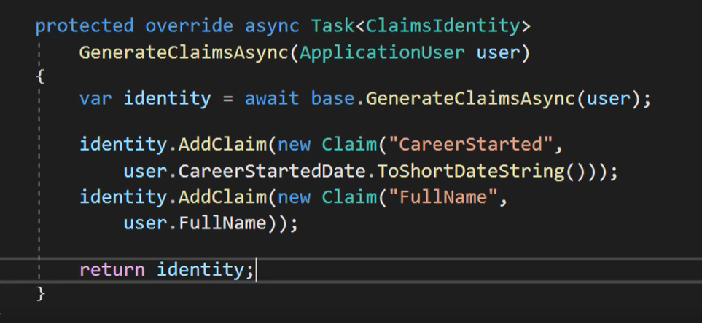

Implement your required claims and return identity.

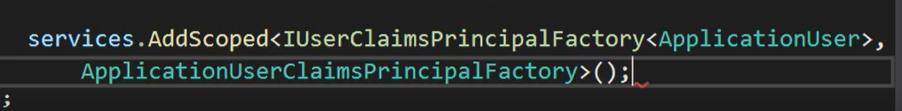

Register new class in services. New claim will be available after reboot.

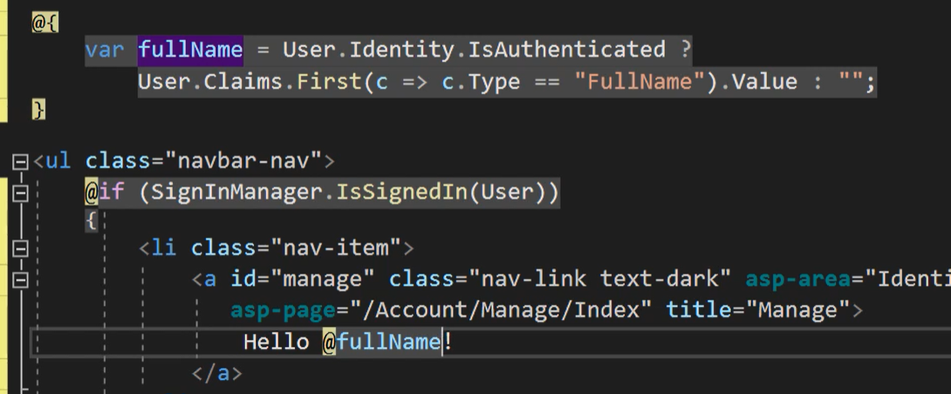

All data can be retrieved with linq instead of claims.

## Roles

Role is role is a specific purpose of user.



Add to service

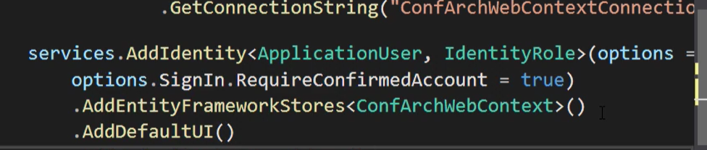

And add default UI if want

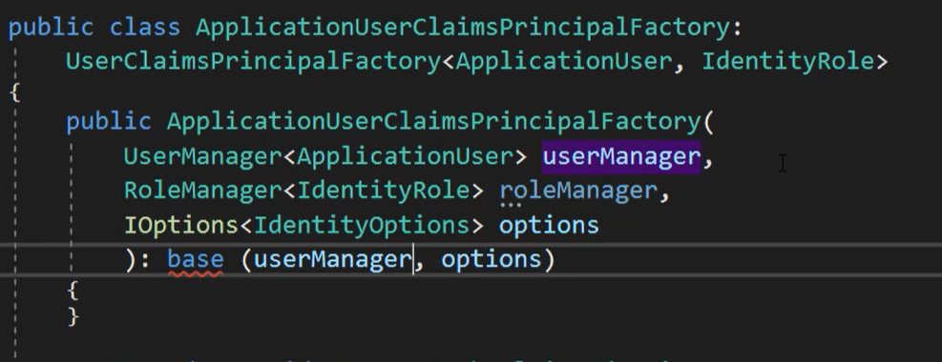

Now role manage can be added to Factory, remember adde IdentityRole

Add role manually to Db by sophisticated technique like copy past.

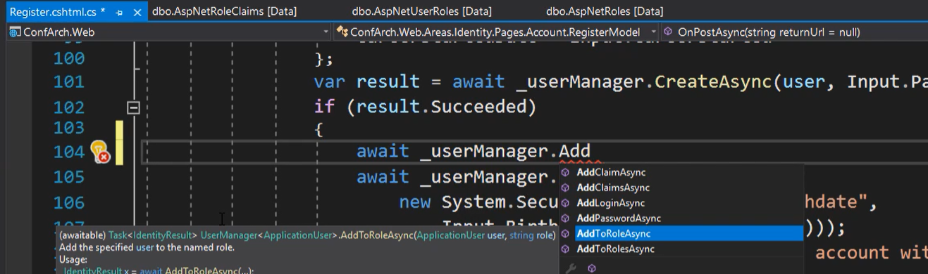

Role can be added in Register.

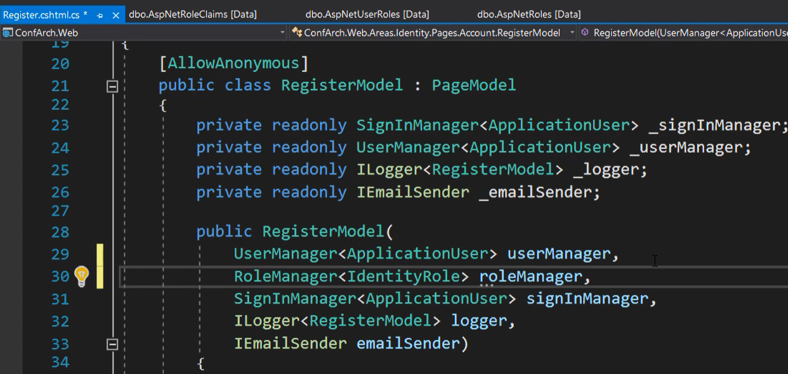

And can be use in Model.

## Email functionality

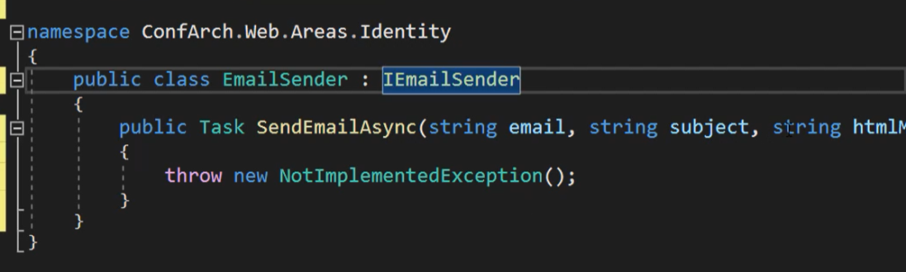

Create class in area.

Create account in SendGrid service and get your API Token, and download package SendGrid via nugget

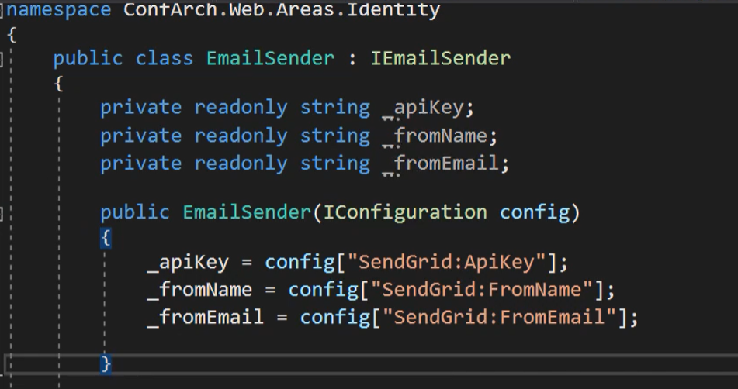

After that create three field and retrive data from config.

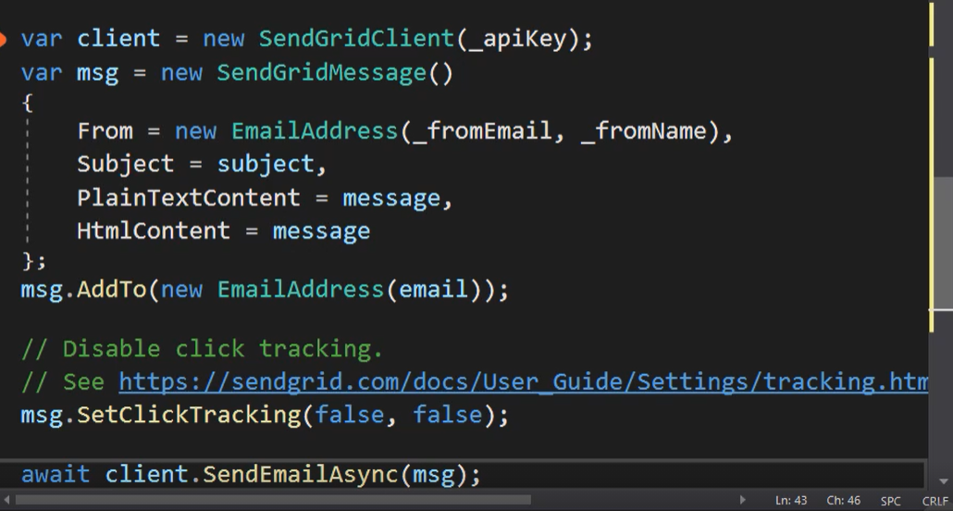

Implement method. Add client with your api. Create SendGrid message add to EmailAddress with email as param. SerClickTrack is for marketing campaigns. Last line send a message.



Register class in DI container. 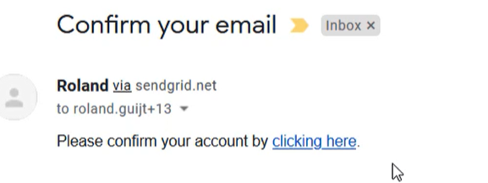

And mail was send with link to confirmation.

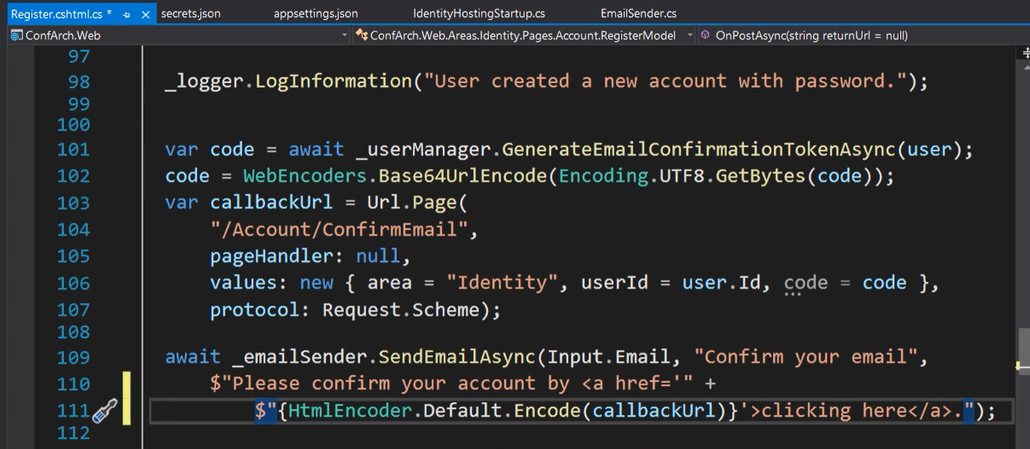

Mail is configured in Register class.

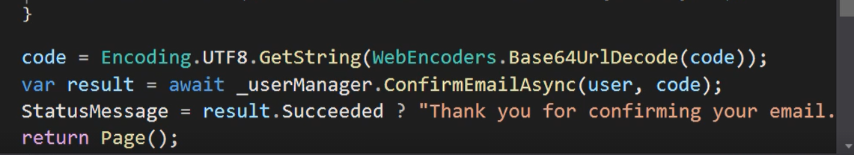

User manager send confirmation of email if user clicked on link.

## Two factor Auth



Download QRCode creator.

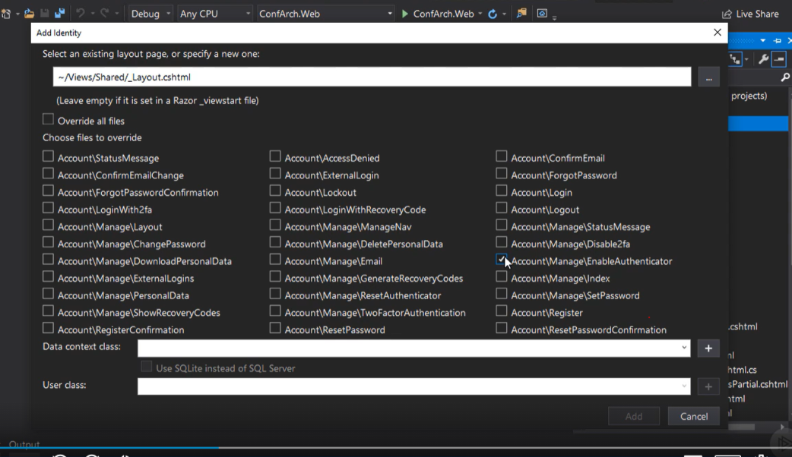

Add scaffolded item EnableAuth

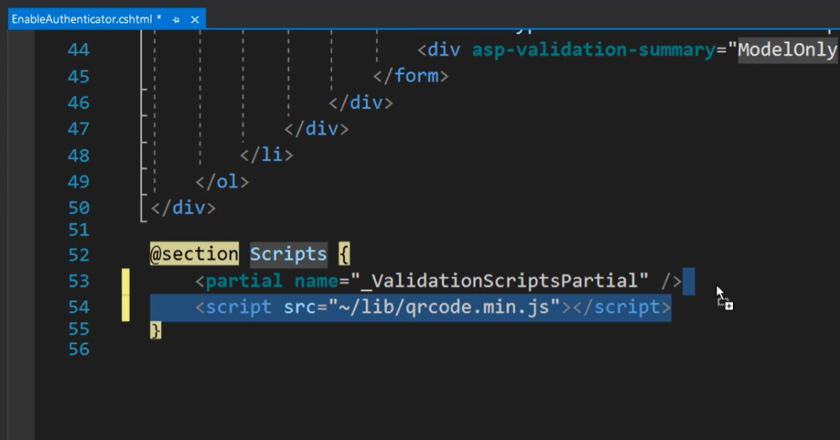

Add js script to cshtml file.

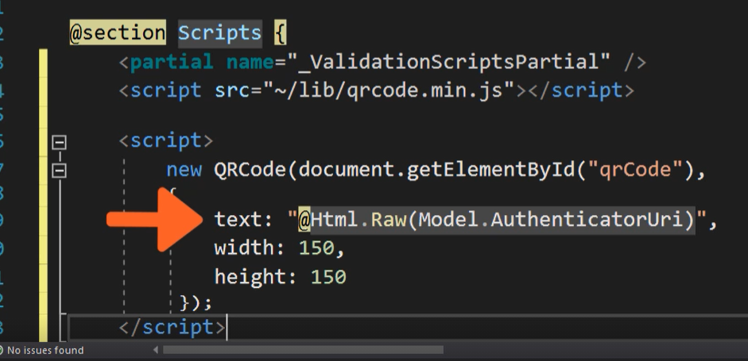

Create new QR code.

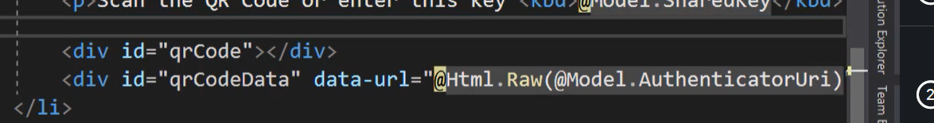

Invoke script.

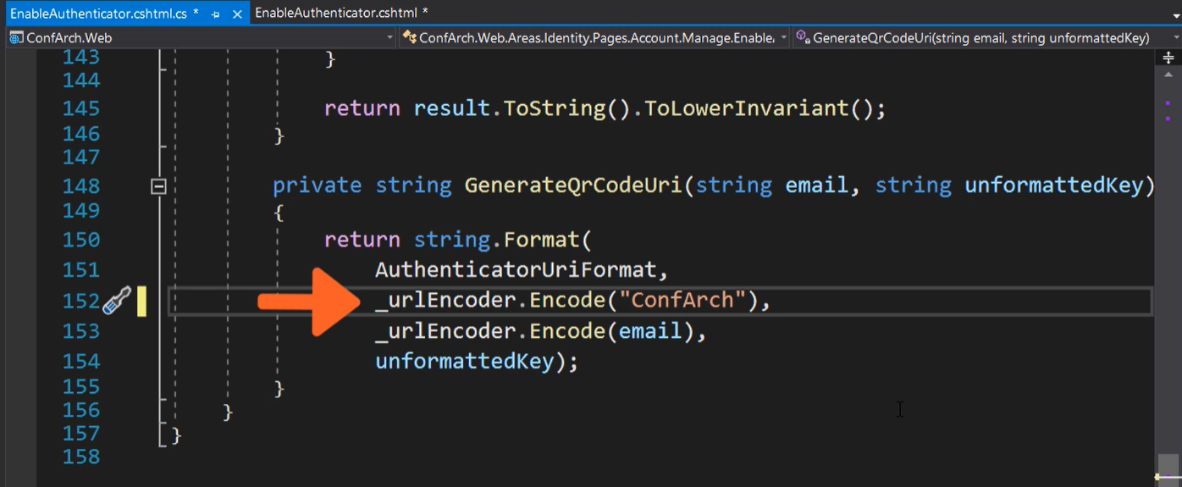

In code behind there is a method which generate a QRCode, second param is App name.

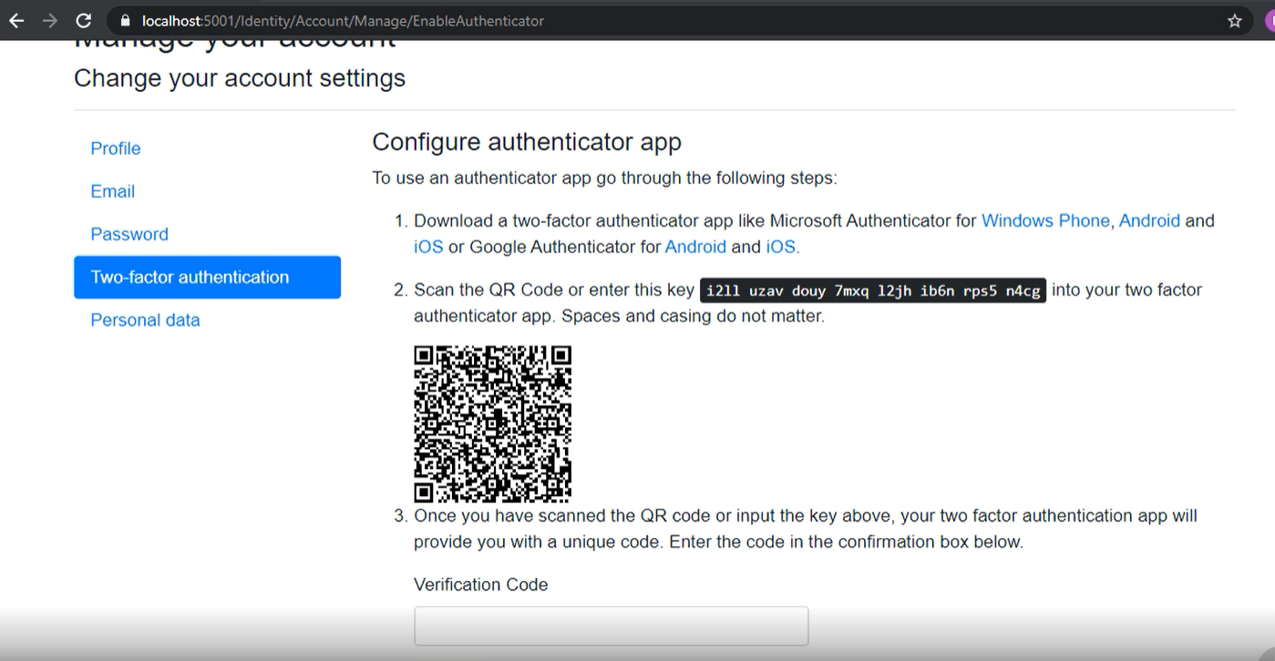

And now we have a code to scan in app.

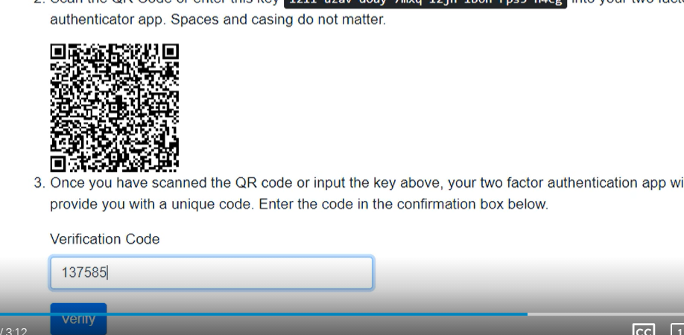 insert code and verify you phone.

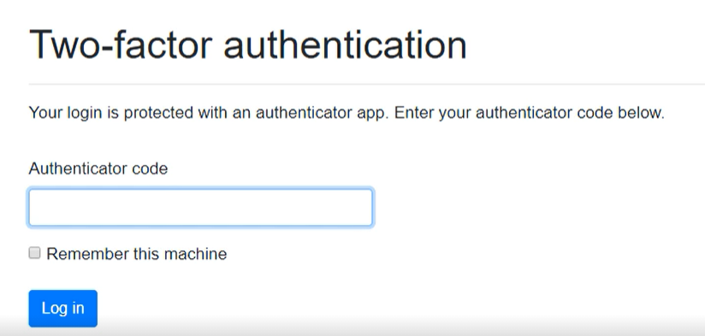

After that required is 2FA to each login operations.

## External Identity Providers

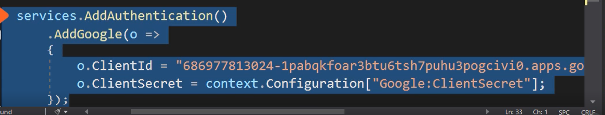

Add package by nugget and create id and secret in google account. It’s works like in session chapter. If would like more information come back to previous chapter.

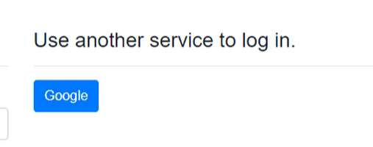

Google button added.

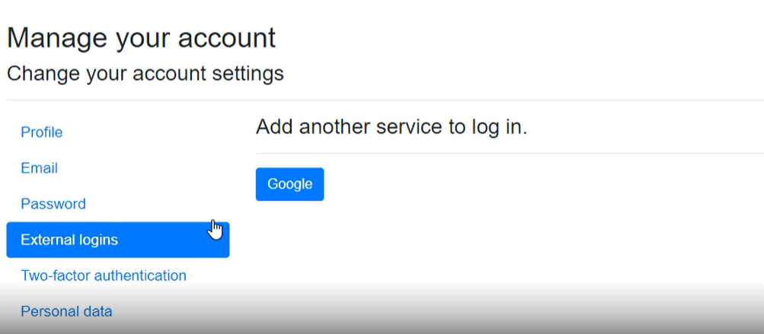

If you have occupied accout because it was used for test add another server in External logins.

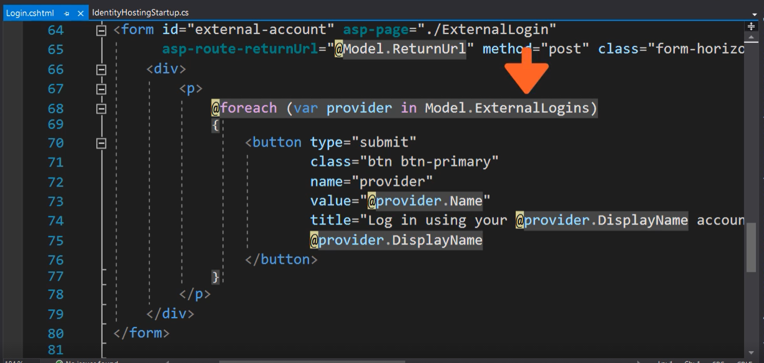

To display logins method use Model.ExternalLogins.

# OpenIDConnect

## Definition

This is special identity provider which get access to different apps in your group.

It’s is single application to rule them all or if you prefer to give access to user when it is possible and required.

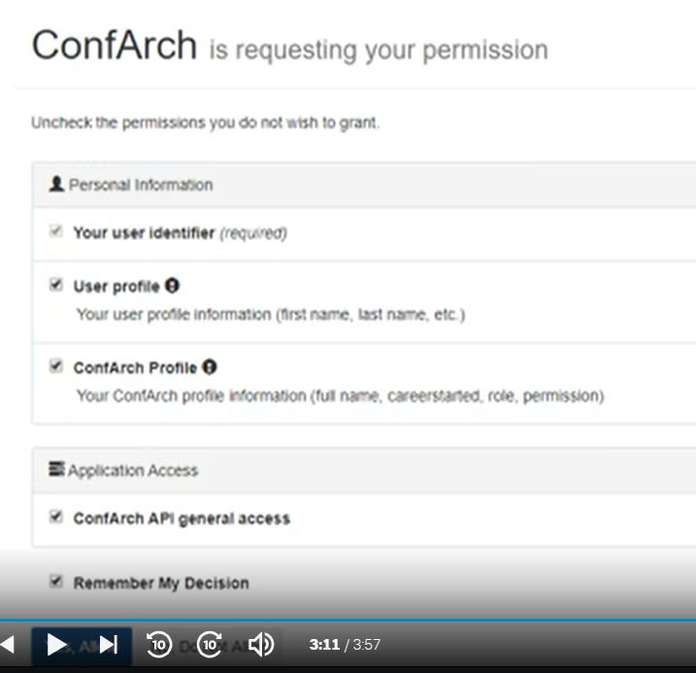

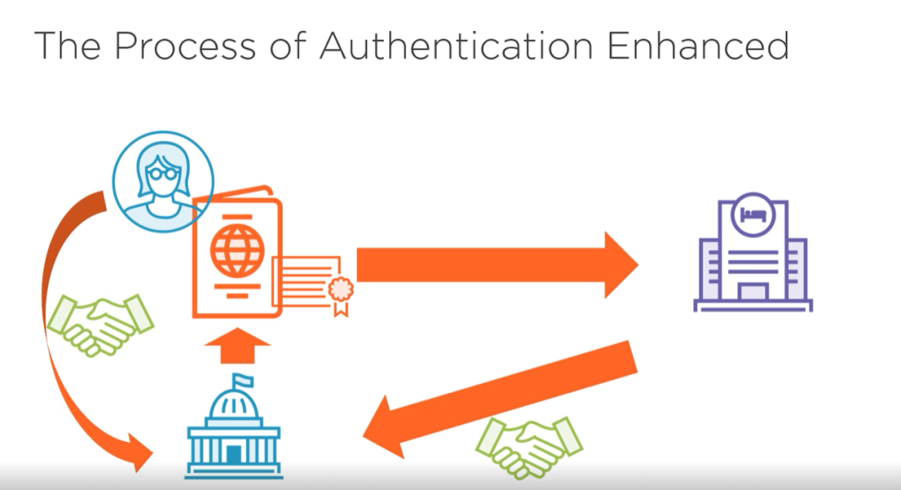

The process of auth with provider. There is a person who would like to book room in a hotel to do this operation hotel services ask for a identity passport this a document to confirm your personal information. National administration issued your ID cart hotel services trust a national organization and you too. A Administration is identity provider which sent information about you, and this information can be used to confirm your identity in different services. In other words personal ID give you access.

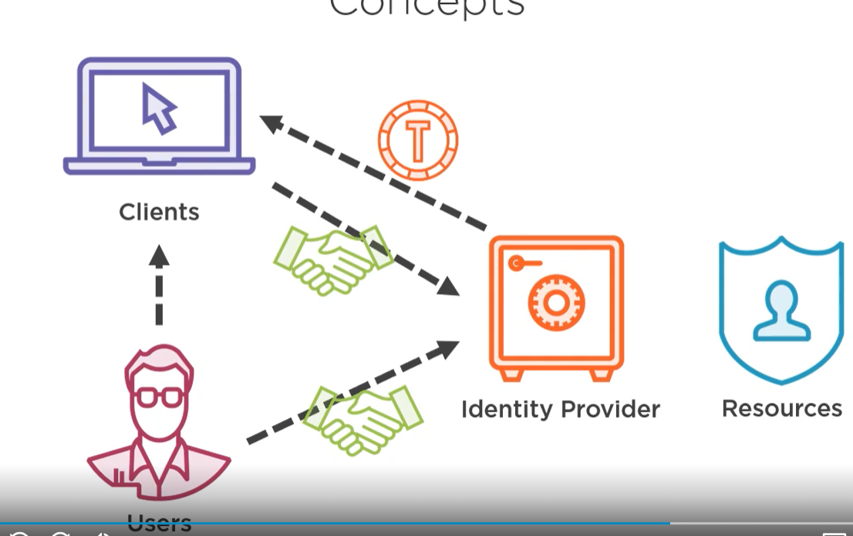

In software example user has accout in resources to this resources has access only identity provider. All data are keep safe so client and user trust to an identity provider. To use services user is asked for identity information. When user Authenticate to identity provider and send information to client then get access to operation in this app. Identity data are send as Token.

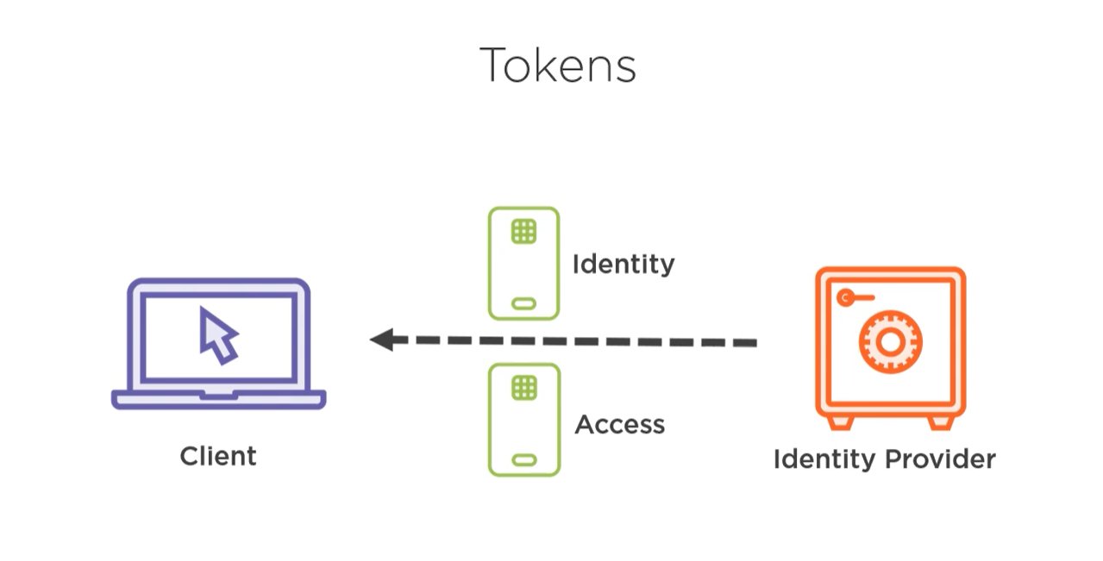

Token is a personal data for the user (Claims) or state of user account. Token can Auth user or check access.

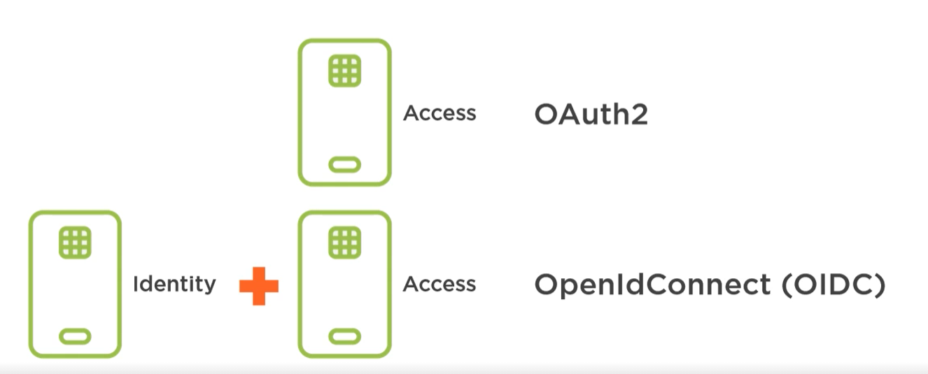

Two standards checking access and checking access and Indentity.

## Implementation

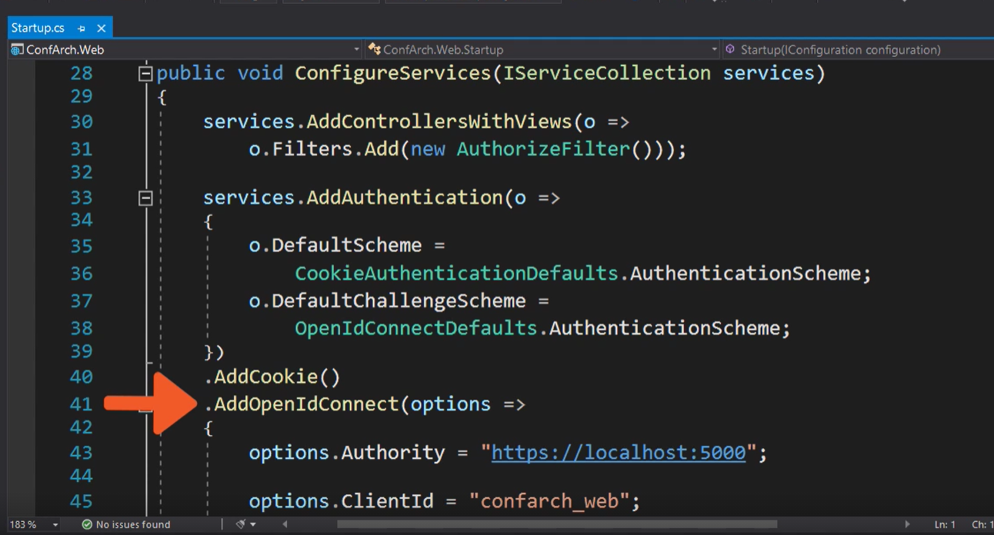

Add Cokie and opeID auth. And pass a option attribute to OpenIdConnect.

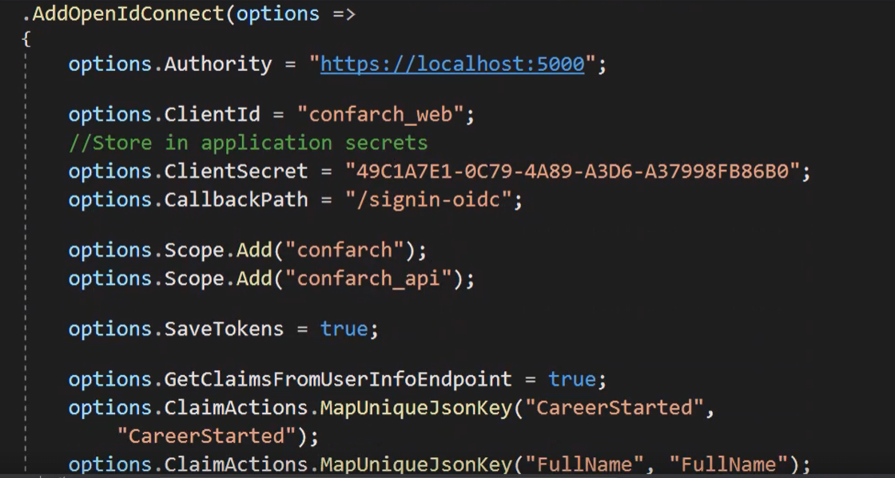

To use secret use application secret don’t paste into production code.

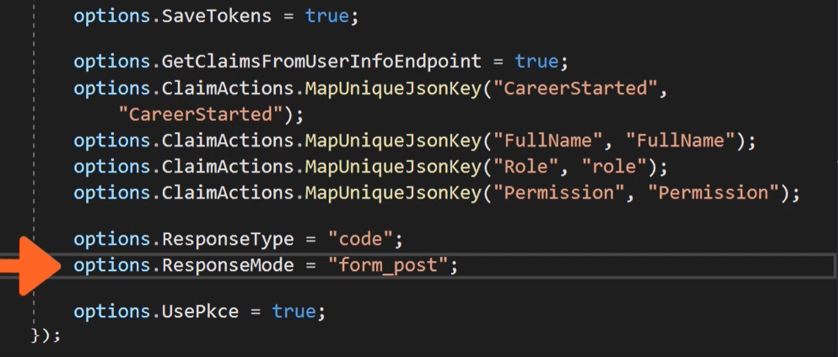

Remember abouot saving token and set response type on code and mode on post method.

## PkCe

Precaution for code substitution attack is a PkCe. Application which create secret to each token and every created token is unique.

When PkCe generate secret and OpenID create code server check both of them and get access or forbade operation.

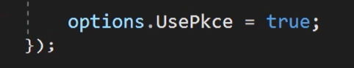

To add PkCe required is only one line.

## Create your own Identity Server

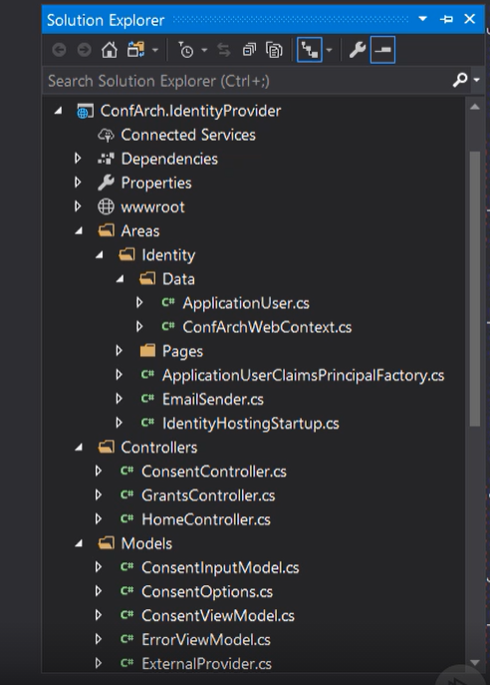

Create project with identity.

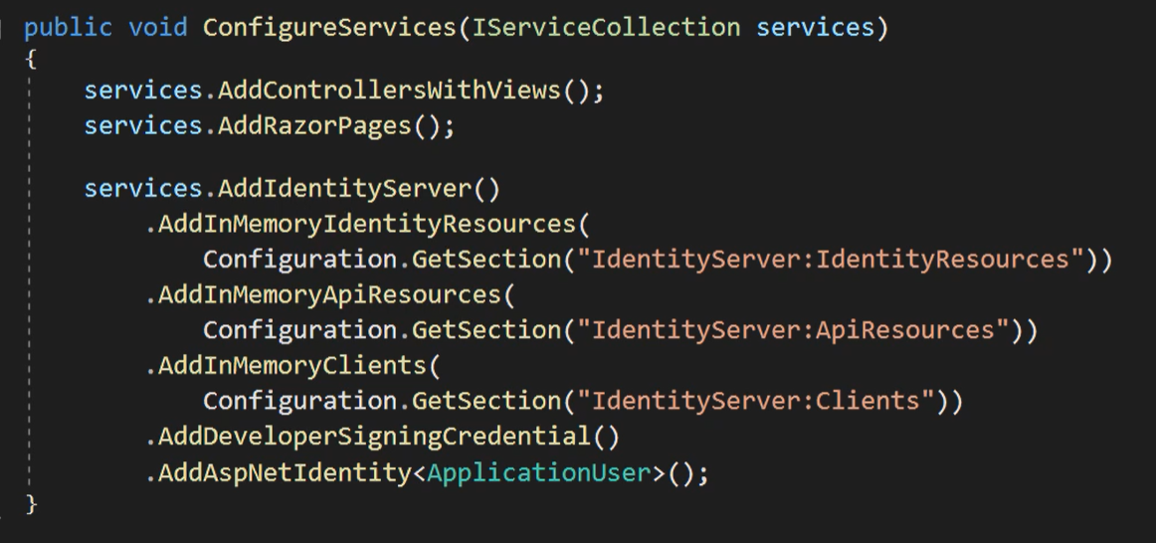

Add configuration and set params. Use your identity type (ApplicationUser). Install package identity server for ASPNet.

Install identityPackage 4 to get all configuration method.

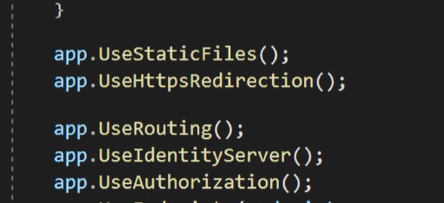

Add middleware. Look on UseIdentityServer.

Identity server can be used as DB but required package Identity Server 4 for EF Core.

## Single Sign On

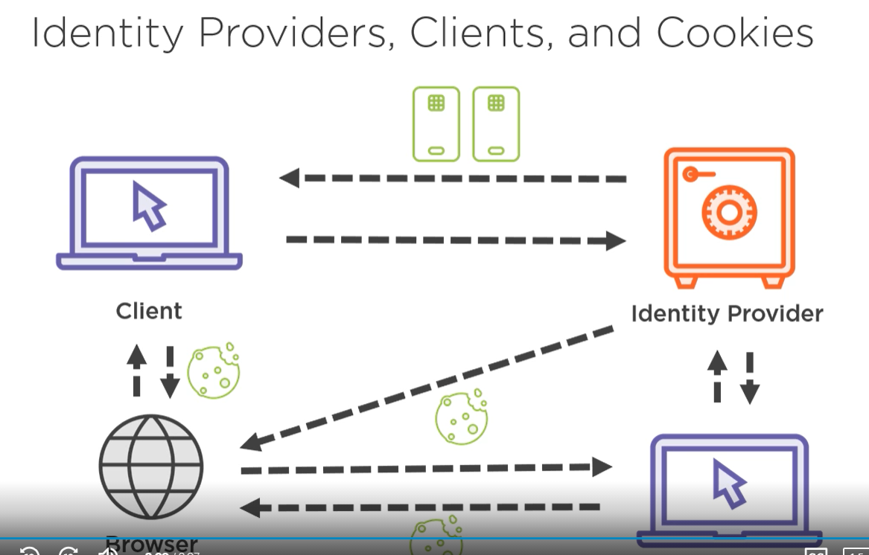

It’s feature when few app use the same identity provider server and when user is login in one app (Identity provider create cookie with claim and give access to app) then user can login in to second one without login operation. Request is redirect to Id provider which check cookies and resend to second app.

## Configure Identity Provider

In lesson before, has been created ID scope which has information information about claims from config. To get all information about config check sourcecode.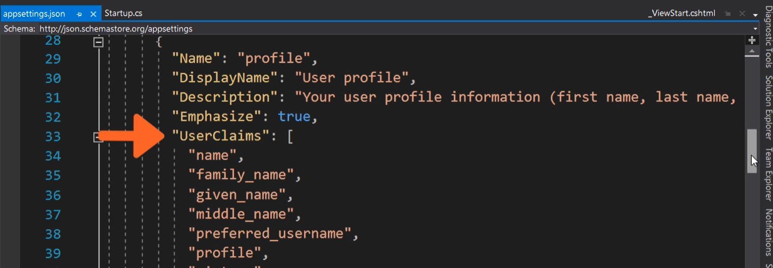

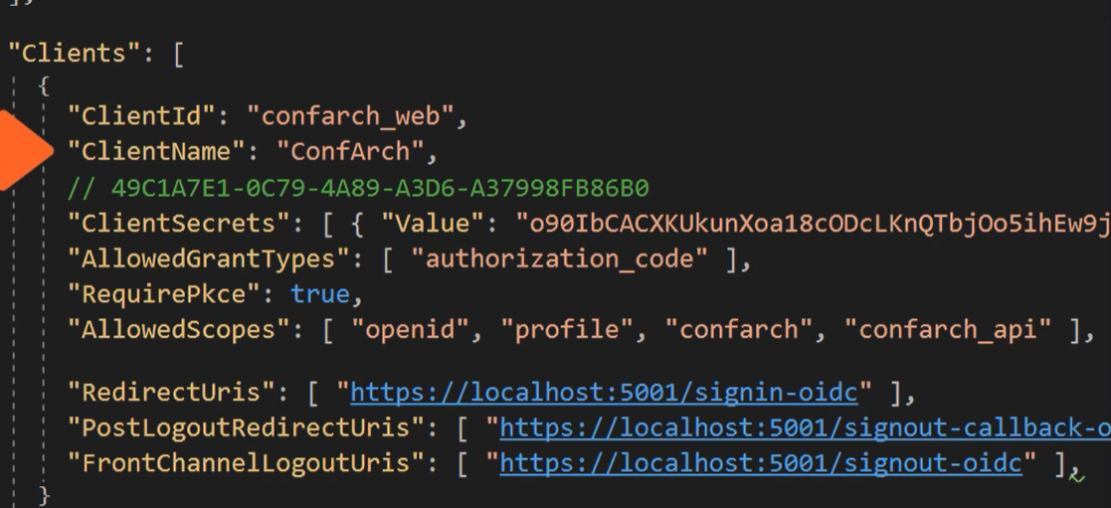

Client configuration whis secret Pkce and urls.

## Protecting API

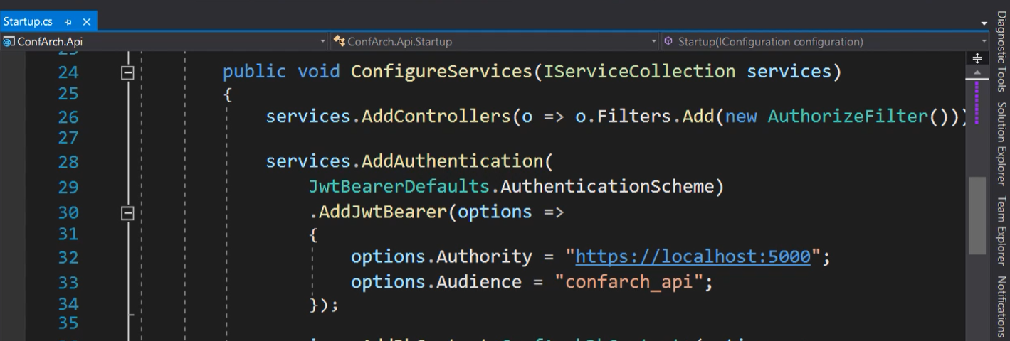

Api required protection with Json web token.

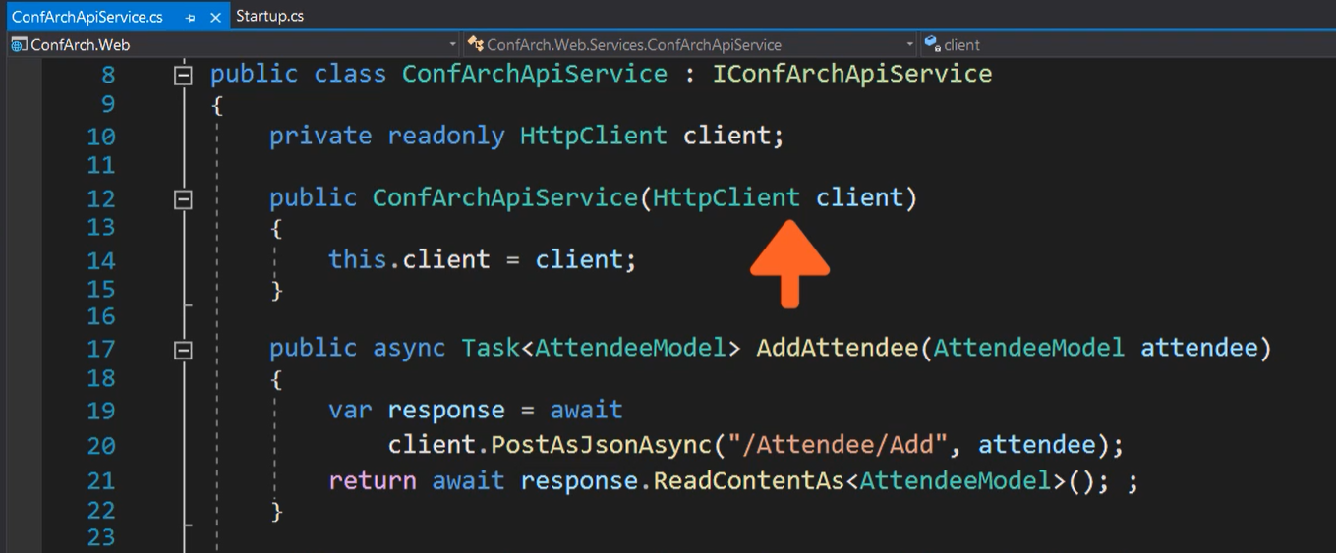

API service use HttpClient to create request.

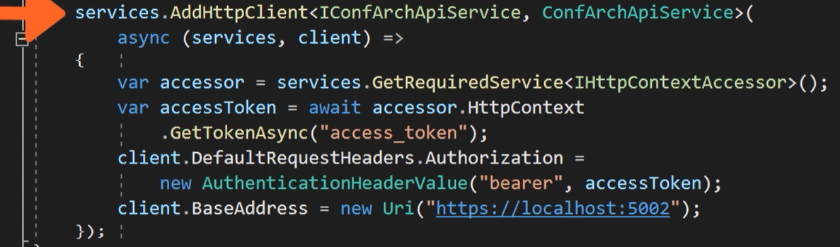

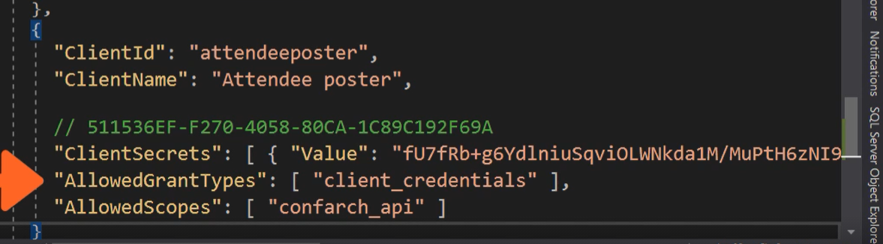

Each client which use a identity provider need be added to config.

More information about this topic on Pluralsight course

<https://app.pluralsight.com/library/courses/authentication-authorization-aspnet-core/table-of-contents>

# Applying Auth

## Definition

Policy is a claims and role in one object Policy.

## Configuration

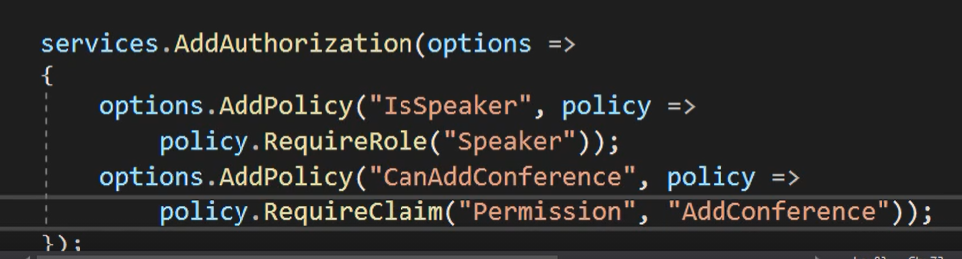

Add Policy as option.

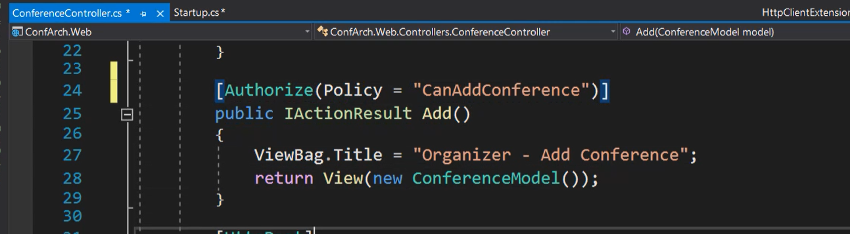

Policy can be used as filter.

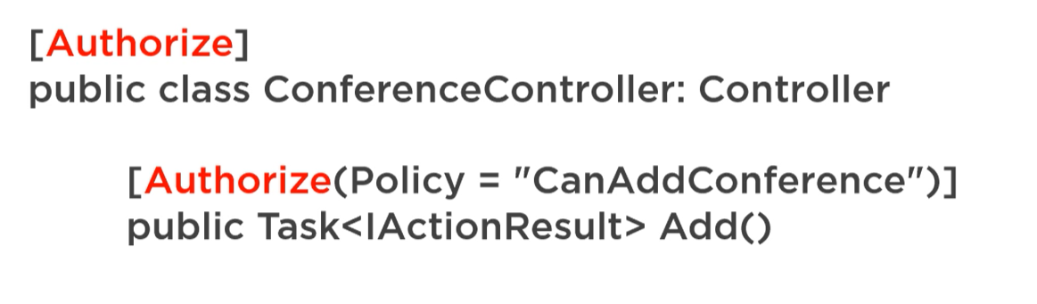

When there are a two authorize filters second one (method) override first one.

## Use in View

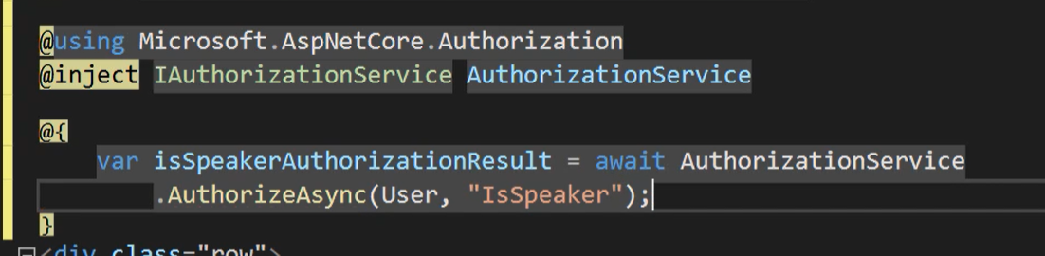

Check auth in view. But always check auth in controller not only in view.

## Requirements and Handler

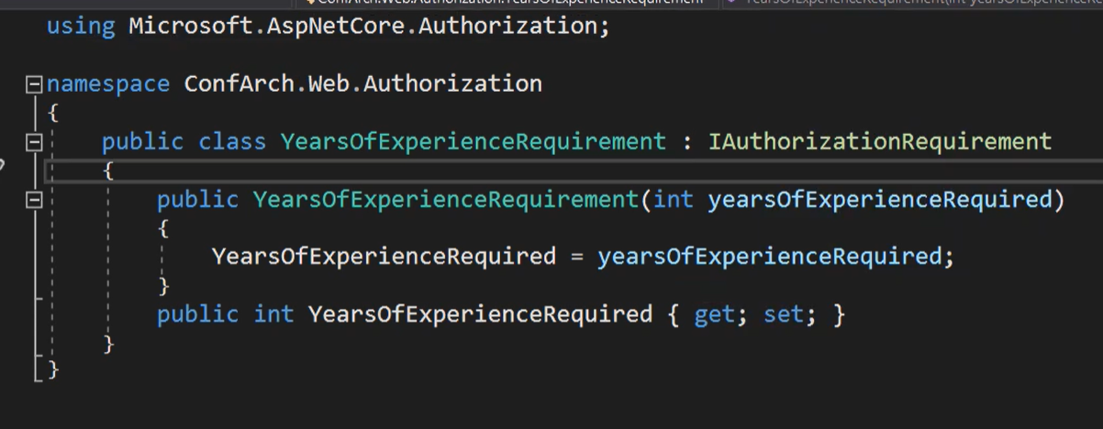

Create cclass with requirements inherit property.

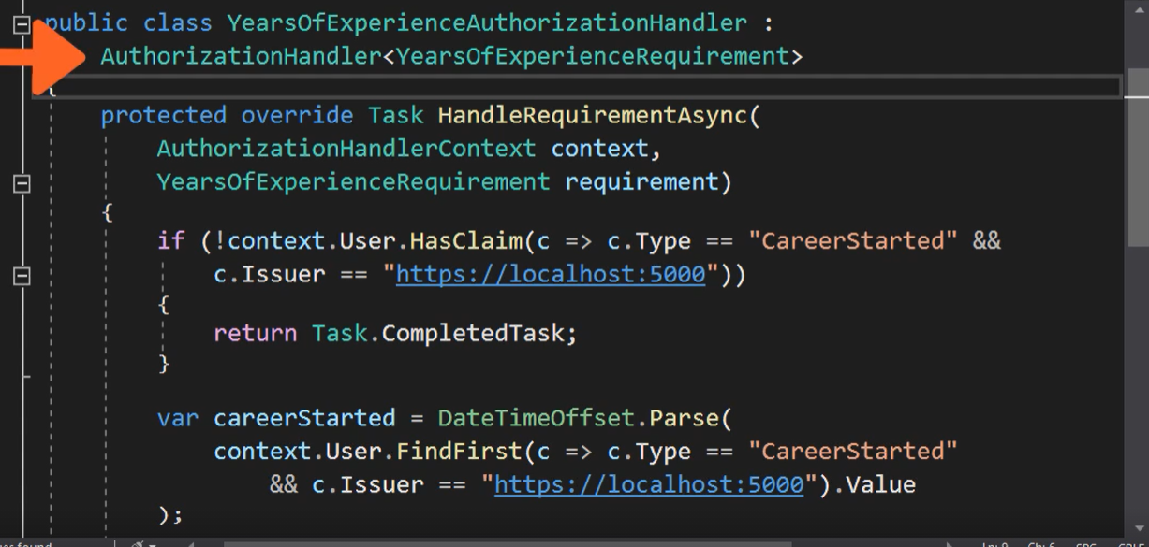

Now create handler with requirements.

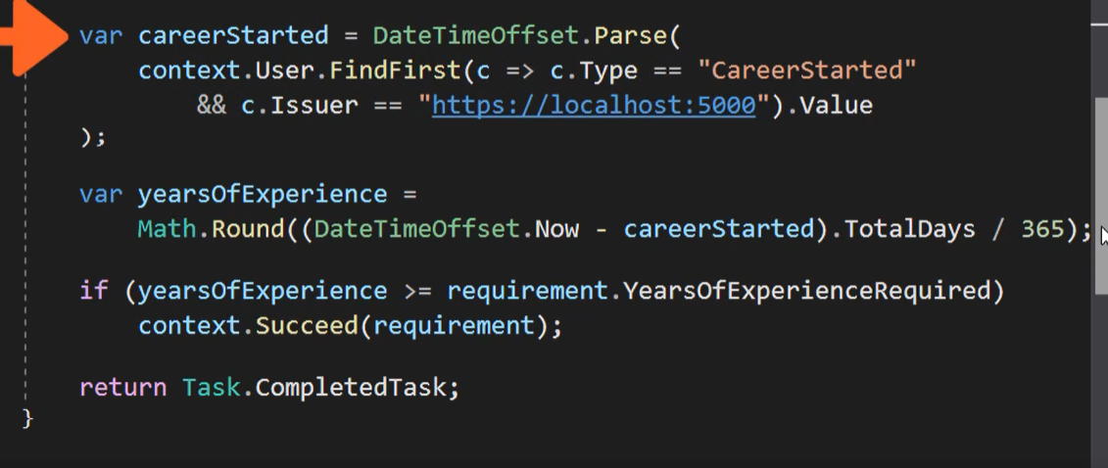

Rest of code.

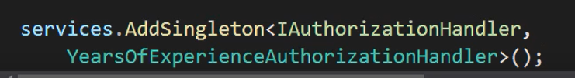

Register service.

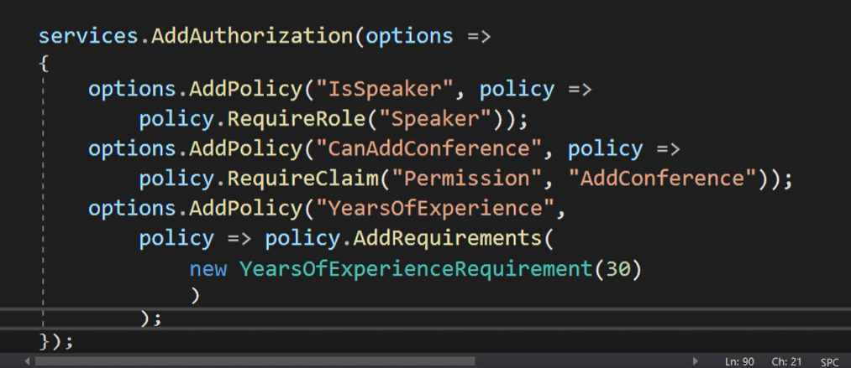

Add policy

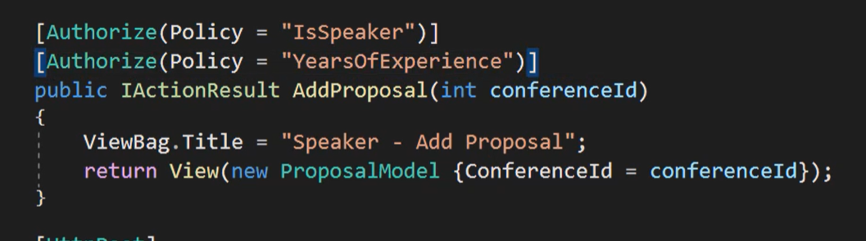

Use your new policy with requirements.

## Proposal

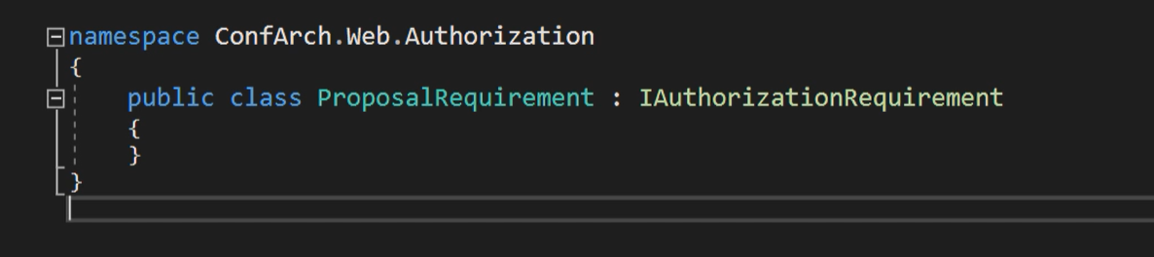

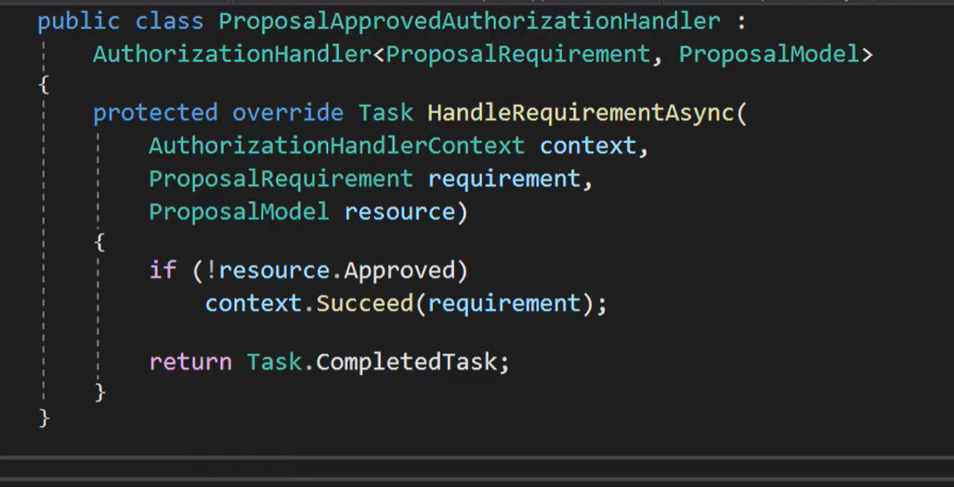

To handler added is Proposal model instance.

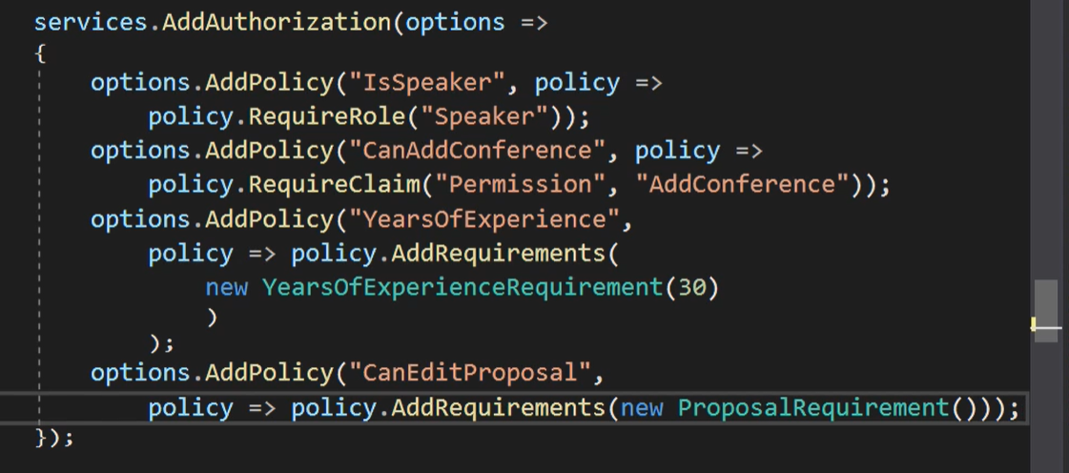

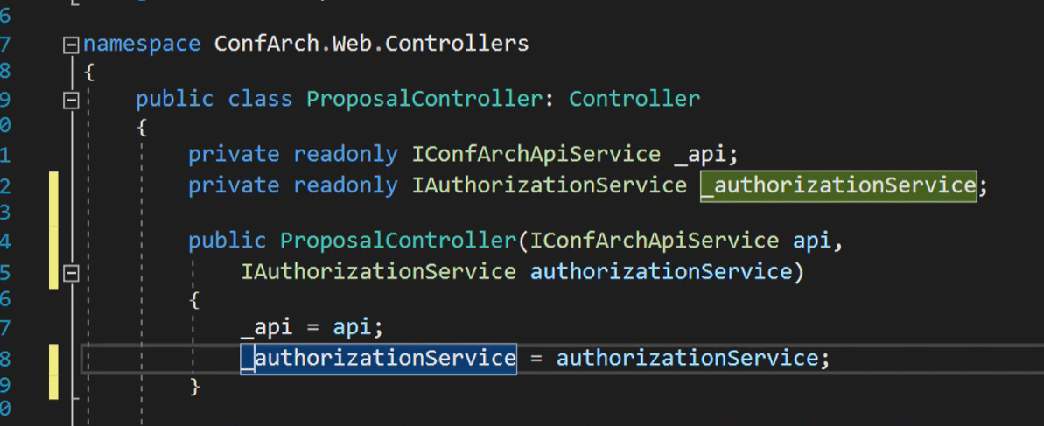

Add auth service to view.

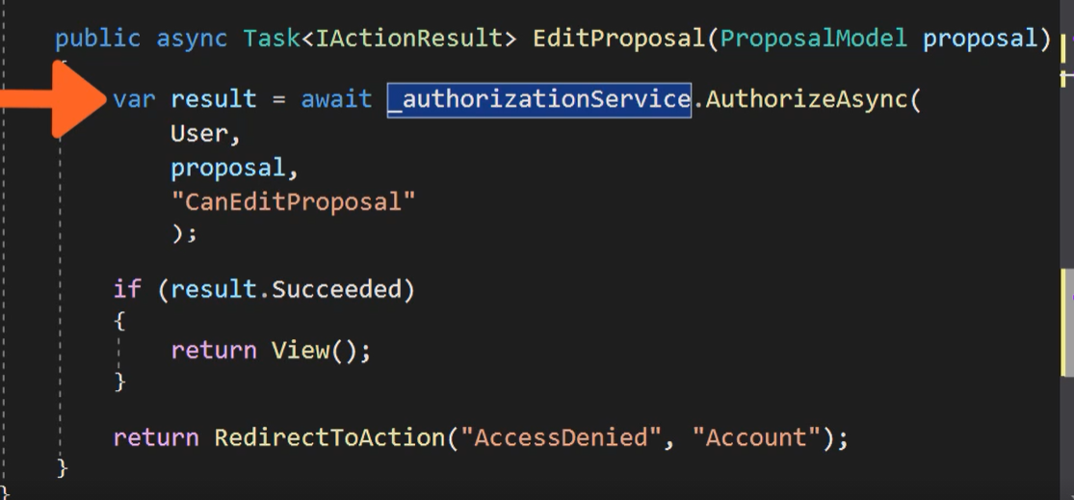

## Auth API

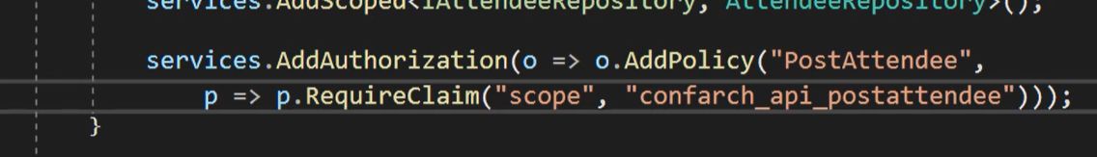

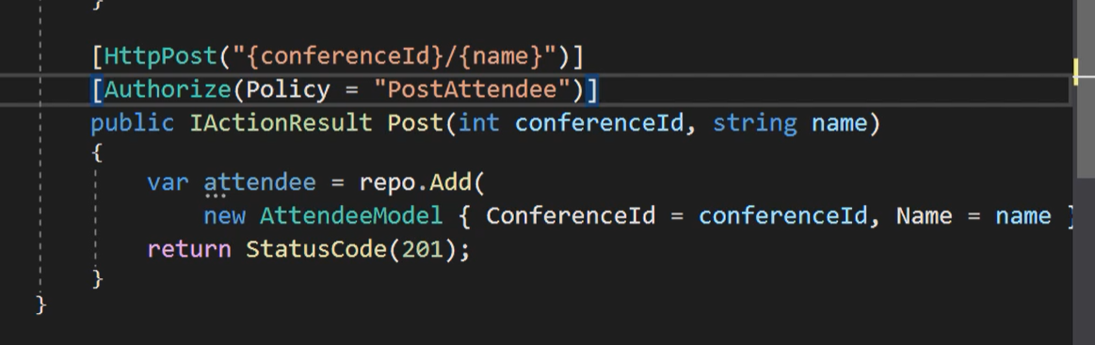

But remember you can authorize like normal view in controller or added auth to OpenID server.

To do auth can be used Toke or Auth APi create by You ☺;